One-zero or pinpoint: which sampling method provides the most accurate assessment of behaviour?

James Edward Brereton1, Jonathan Tuke2 and Eduardo J Fernandez3

1University Centre Sparsholt, Westley Lane, Sparsholt, Winchester, Hampshire, SO21 2NF United Kingdom

2School of Mathematical Sciences, The University of Adelaide, SA 5005, Australia

3School of Animal and Veterinary Sciences, The University of Adelaide, SA 5005, Australia

*Correspondence: +447748354279; [James.Brereton@sparsholt.ac.uk](mailto:James.Brereton@sparsholt.ac.uk); [edjfern@gmail.com](mailto:edjfern@gmail.com)

Original Research paper

**Running title:** Comparison of behavioural recording methods

**Abstract:**

*Keywords:* continuous recording, pinpoint sampling, one-zero sampling, measuring behaviour

**INTRODUCTION**

The measurement of behaviour has become a major area of scientific study for those involved in the scientific study of animal behaviour. Behavioural studies are used as a tool to measure captive animal welfare, and are used more often than other welfare indicators such as glucocorticoid analysis (Fraser, 2009; Sands & Creel, 2004). For captive animals, behavioural research may also be used to investigate the prevalence of positive behaviors, such as foraging, or negative behaviors, such as stereotypies (Carlstead, Baldwin, & Seidensticker, 1991; Fernandez & Timberlake, 2008; Ward, Sherwen & Clark, 2018). Studies of behaviour are also frequently conducted for wild animal populations, to better understand natural history or investigate the impact of human disturbance (Lehner, 1998; Sand & Creel, 2004). Research on animal behaviour is now so well recognised that there are numerous journals dedicated to its study, for instance: *Animal Behaviour,* *Applied Animal Behaviour Science, and Ethology.*

The methods used in animal behavior research can be traced back to human studies. Scientists during the mid-twentieth Century often used a mixture of both human and animal models to answer questions in the field of behavioral psychology (Domjan, 2014; Pierce & Cheney, 2013). Based on the range of different techniques that were generated by earlier studies, Altmann (1974) summarised the behavioural research methods available. This paper became fundamentally important to those interested in behavioural research, and remains a keystone paper for researchers, with at least 16,100 citations, according to a search on Google Scholar (2020). Whilst other authors, such as Martin and Bateson (2007) further refined the behavioural methods and their definitions, Altmann’s work is still regularly cited.

Since this initial review of behavioural methods, some behavioural sampling techniques became increasingly popular in animal literature, whereas others are rarely used. Several behaviour measurement techniques have received some criticism in terms of their repeatability (Bernstein, 1991). For example, ad libitum (qualitative) sampling may be useful for developing ethograms and for pilot studies but has methodological flaws with regards to its lack of standardisation (Martin & Bateson, 2007; Rhine & Ender, 1983). However*, ad libitum* sampling is still used in animal behaviour literature, with a review by Mann (1999) identifying that between 53% and 59% of cetacean studies published in *Marine Mammal Science* used this sampling technique.

Continuous recording, or focal sampling, is considered the gold standard for behaviour sampling, as this method records all occurrences of behaviour and their durations (Hämäläinen *et al*., 2016). In the past, this made continuous recording challenging for researchers, as an active animal that rapidly changed behaviour would have been difficult to gather representative data for (Tyler, 1979). Similarly, the recording of multiple animals using a continuous method would have been incredibly challenging to record accurately, hence why the method is considered synonymous with focal sampling of one individual (Altmann, 1974; Martin & Bateson, 2007). Use of modern technology has in part ameliorated some of these issues by allowing behaviour to be recorded and analysed later (Amato *et al.*, 2013). However, continuous recording may remain a challenge, even with camera availability. As a result, several sampling methods have been developed to measure multiple animals at one time (scan sampling), as well in a non-continuous fashion.

The use of pinpoint sampling, also referred to as instantaneous or momentary time sampling, is a commonly used method for observational study (Fernandez, Kinley & Timberlake, 2019; Stevens *et al.*, 2013). With pinpoint sampling, one or more responses are recorded at preselected moments in time (e.g., every 15 s for an hour). The benefits of instantaneous sampling are that it is less intensive than continuous sampling, and therefore may be more feasible for researchers to conduct (Grenier *et al.*, 1999; Martin & Bateson, 2007; Rhine & Flanigon, 1978). The methods are also more versatile, allowing researchers to make decisions as to how long intervals should be spaced. For example, some researchers might choose to use 15-second intervals, particularly when studying an active animal or when conducting observations of a key time period, such as when enrichment is provided (Fernandez & Timberlake, 2019). On the other hand, observers might choose to use much longer intervals, such as one, two or five minute intervals when their subjects are inactive or if they are observing for long time periods (Shora, Myhill & Brereton, 2020; Teixeira et al., 2017). It has been noted by some authors that shorter intervals tend to result in behavioural values that match more closely the continuous behaviour scores (Pullins *et al.*, 2017).

One-zero or interval sampling involves choosing specific intervals of time, like pinpoint sampling, but instead recording whether one or more responses occur (or conversely, do not occur) within that interval of time (Bailey & Burch, 2017; Lehner, 1998). While popular with both human and non-human primate research, one-zero sampling seems to receive less representation than pinpoint sampling in most animal behavior studies and has been criticised in by previous researchers (Altmann, 1974; Rhine & Flanigon, 1978). However, one-zero sampling has some of the same benefits of instantaneous sampling, in that interval length can be tailored in line with the requirements of the study. Additionally, one-zero sampling has the potential to collect more behaviours during a stated period, as multiple behaviours can be recorded during each interval (Altmann, 1974). Leger (1977) identified good agreement with continuous behaviour measures when using one-zero sampling at 15-second intervals for chimpanzees (*Pan troglodytes)*. Likewise, Gilby, Pokempner, and Wrangham (2010) found similar levels of occurrence when comparing continuous and one-zero sampling methods for the foraging behavior of wild chimpanzees. As noted above, one-zero (interval) sampling is also frequently used in studies on human behaviour, for example in the classroom (Dunkerton, 1981; Omark et al., 1976).

Both pinpoint and one-zero sampling overcome some of the issues associated with continuous recording by reducing the amount of input required by the researcher, while still aiming to keep the sample representative of the animal’s behavioural repertoire (Mitlöhner *et al.*, 2001; Simpson & Simpson, 1977). However, one key question is how closely these techniques correlate with continuous recording? Instantaneous sampling is reported to lose information in terms of behaviour duration and is potentially less likely to pick up any behaviours of short duration (events) (Martin & Bateson, 2007; Xiao *et al.*, 2005). By contrast, one-zero sampling is better at recording all observable behaviours, but both behavioural frequency and duration could be easily misrepresented: there is no way to identify whether a behaviour recorded as present for one interval was seen once or thirty times during that time period (Saibaba *et al.*, 1996).

The following study proposes to compare simulated occurrence of both low, medium, and high frequency/duration behaviours, as well as similar observation periods and for both pinpoint and one-zero sampling methods. We hypothesized two results: (1) pinpoint sampling would provide a more accurate representation of percentages of occurrence for both low, medium, and high duration behaviors than one-zero sampling, and (2) one-zero sampling would be better suited for detecting the occurrence of low frequency behaviors, particularly when comparing less frequent pinpoint and one-zero observation methods (e.g., 5 min observation periods).

.

**METHODS**

For all simulations, continuous recording methods were generated for both frequency of occurrence and percentage of occurrence, with two different non-continuous sampling methods directly compared: pinpoint (instantaneous) and one-zero (interval) sampling. Independent variables were split into two categories: Response frequency (to measure the ability of both behaviour methods to detect short, event behaviours) and response duration (to measure the ability of the methods in assessing long term, state behaviours). Three levels for response frequency and response duration were determined, based on an arbitrarily level of occurrence: 3 s, 30 s, and 300 s. The interval lengths for both pinpoint and one-zero sampling were set at 5 s, 50 s, and 500 s, in order to compare the effect of interval length on test accuracy.

***Response frequency***

This simulation focused on the recording of event behaviours: behaviours of very short duration (Martin & Bateson, 2007). For the purpose of the simulation, the duration of all event behaviours was set to exactly one second. Next, three different frequencies of event behaviour were selected: these consisted of frequent (occurs every three seconds), moderate (occurs once every 30 seconds) and infrequent (occurs every 300 seconds). Simulated data sets were developed for each of the three behavioural frequencies. These simulated data sets were 1 hour in length (3600 seconds). A total of 100 simulated data sets were generated for each of the three response frequencies. The exact time that each event occurred within the 3, 30 or 300 second period was randomised (e.g. Figure XXX).

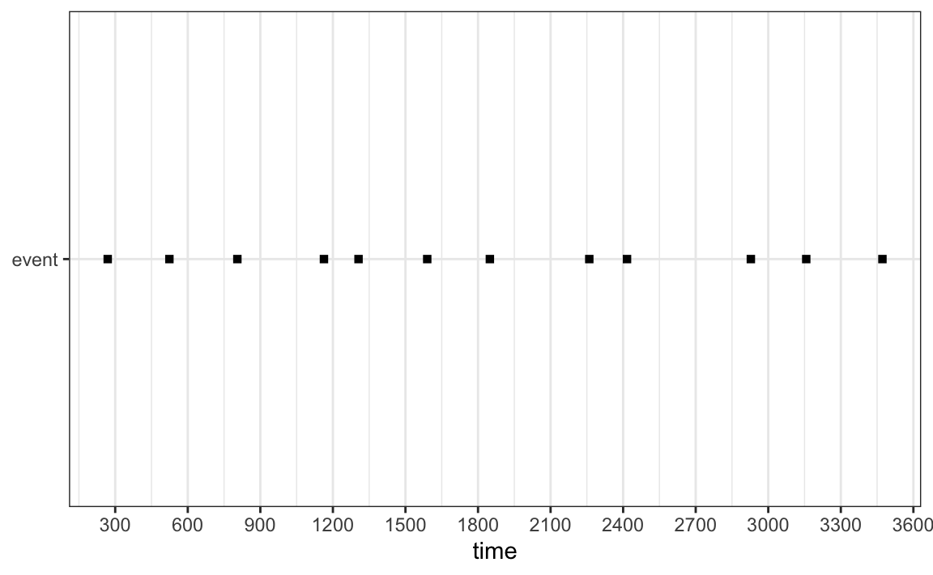

***Figure XXX.*** *Example of simulated data set to show how each event was presented. This figure shows the location of each event when events were set to infrequent (occurs once per 300 seconds). The exact location of each event within its 300 second window was selected using at random.*

A continuous data set was developed by calculating the number of seconds of event behaviour that occurred in simulated hour of data (1200 s for the frequent behaviour, 120 s for moderate behaviour, and 12 s for the infrequent behaviour respectively). The event behaviour seconds were then transformed into a percentage of total time (as is often shown in behaviour studies in the form of an activity budget), as well as frequency of occurrence.

To compare against this continuous data, or ‘actual behaviour’, one-zero and pinpoint sampling were used on the simulated data sets. Three interval lengths (5 s, 50 s, and 500 s) were used for both pinpoint and one-zero sampling. This resulted in nine-hundred data sets (nine combinations of simulation parameters and sampling parameters, each combination simulated 100 times) being developed.

The data generated from the pinpoint and one-zero sampling was then converted into percentages to compare against the continuous data. The error rates for one-zero and pinpoint sampling were calculated for each of their three interval lengths.

***Response duration***

This simulation was developed for long-duration or state behaviours. In the literature, state behaviours can be of variable length, lasting anywhere from seconds to hours. In order to accommodate this, three levels of behavioural duration were selected. These durations were set as short (3 s), medium (30 s) and long (300 s). Each of the behaviours was treated separately (only short, medium or long behaviours occurred in each simulation.

As per the *Response frequency* investigation, the observation period was set to one hour in length (3600 seconds). Each behavioural duration simulation was repeated 100 times.

The chosen behaviour occurred once per 600 s period. The exact time that each behaviour occurred within its respective 600s period was selected at random (though the behaviour was not allowed to slip into the next period of 600 s). Continuous data sets were developed by using the raw, simulated data and transforming this into percentages. This meant that each behaviour occurred six times during each hour simulation, with the long behaviour taking up 50% of the hour, the medium behaviour taking up 5%, and the short behaviour 0.5% of the time.

Each of the three behaviour durations (short, medium and long) were measured using one-zero and pinpoint sampling. Three interval lengths, again consisting of 5 s, 50 s and 500 s, as had been selected for the *Response frequency* investigations (Figure XXX). These interval lengths were used for both the one-zero and the pinpoint sampling. Once complete, the results were then transformed into percentages and compared to the continuous data to determine the level of error.

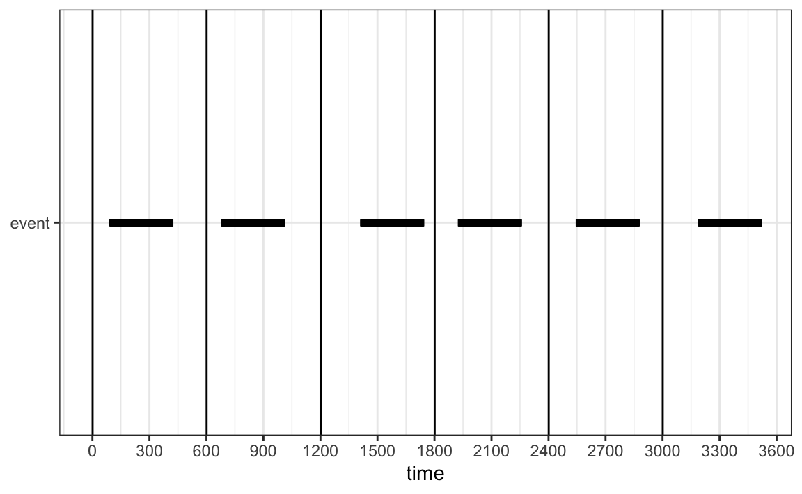

***Figure XXX.*** *Example of simulated data for the response duration for long (300 s behaviours). The location of each behaviour has been selected at random within its 600 s period. This results in the behaviour occurring for exactly 50% of the hour simulation.*

***Simulations and Statistical Analysis***

Simulations were computer-generated using the R language . Statistical analysis was conducted on the mean error scores for the one-zero and pinpoint sampling at each respective interval length. The Friedman test was used to investigate whether there was a statistically significant effect of sampling method on the estimation error. The sampling / simulation combination was used as a blocking factor. The non-parametric Friedman test was used due to the non-normality of the errors and the observed heteroscedascity.

All code is available at https://github.com/jonotuke/animal_simulation_2020

**RESULTS**

***Response frequency***

The accuracy of both one-zero and pinpoint sampling was calculated for each interval length and each of the three behavioural frequencies) (Figure XXX, Table XXX). Overall, mean error rates were consistently lower for the pinpoint sampling method in comparison to the one-zero sampling method. For both behavioural sampling methods, error rates increased as the interval length increased, with the 500 s interval showing the largest error rates and variation for both one-zero and pinpoint sampling.

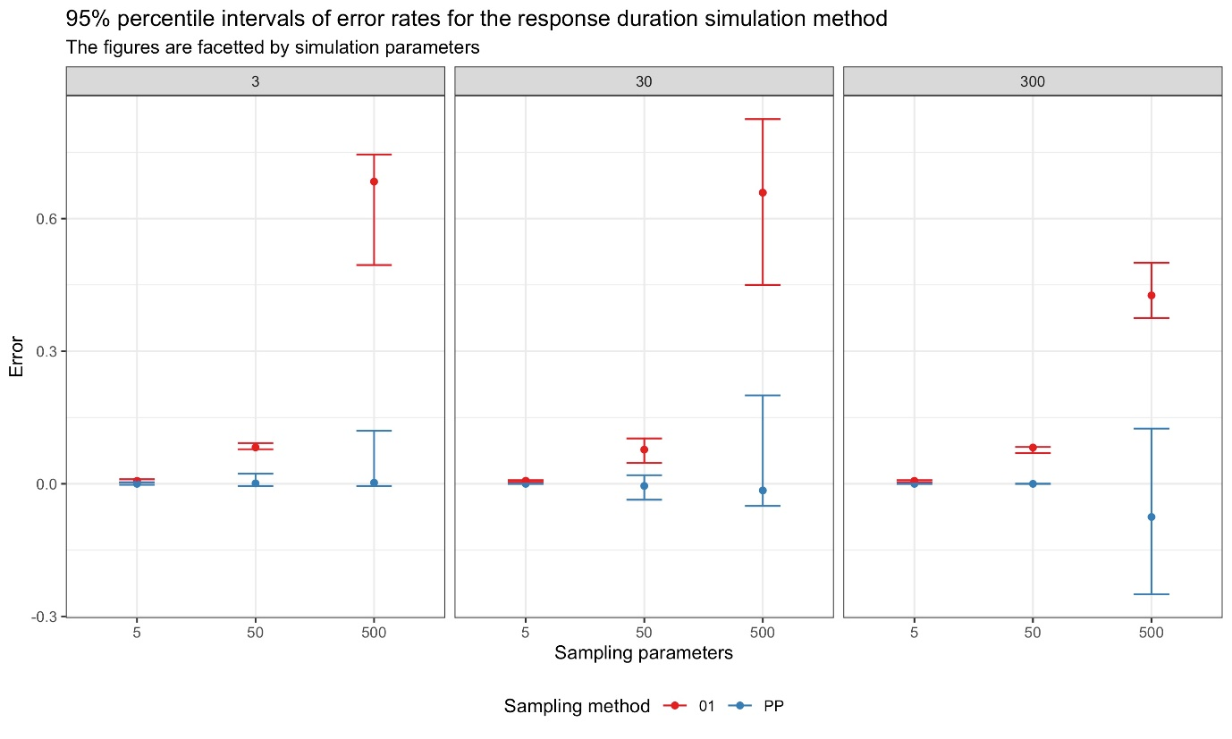

***Figure XXX.*** *Mean error rates for pinpoint and one-zero sampling methods at the 5s, 50 s and 500 s intervals. Error rates were higher for the longer interval periods, and were consistently higher for the one-zero sampling method. PP: Pinpoint sampling, 01: One-zero sampling.*

***Response duration***

The accuracy of both one-zero and pinpoint sampling was calculated for each interval length and all three behavioural durations (short, medium and long) (Figure XXX, Table XXX). For the short duration behaviours, one-zero sampling had a consistently high error rate. One-zero sampling was in fact accurate only when interval length was short (5 s) and the behavioural duration was medium or long. Pinpoint sampling error rates were generally lower than those from one-zero sampling, though variation in scores tended to increase as interval lengths became longer.

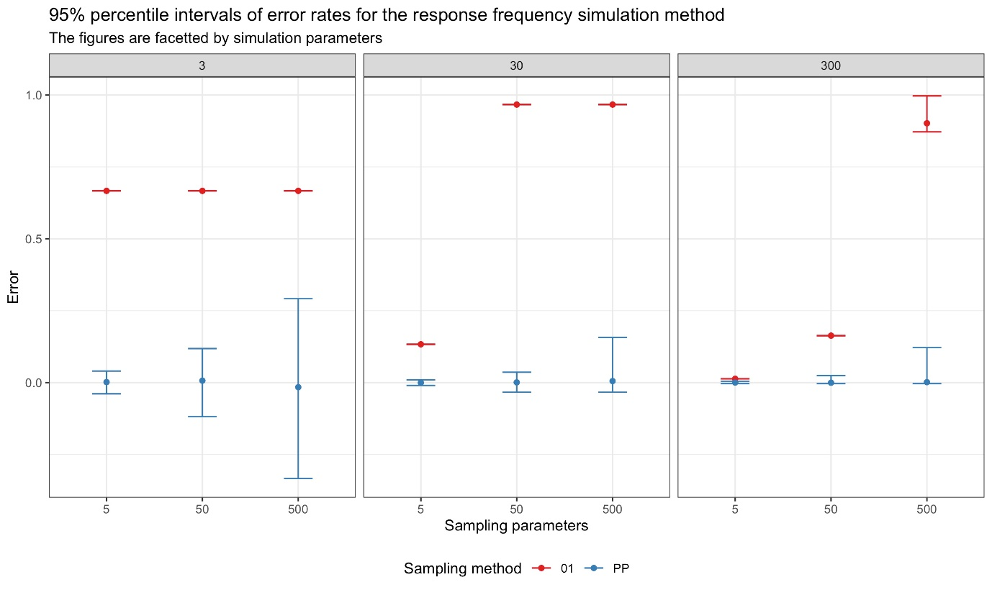

***Figure XXX.*** *Mean error rates for both one-zero and pinpoint sampling for the 5 s, 50 s and 500 s intervals. There was more variation in error rates for the pinpoint sampling as interval length grew longer, but average mean error rates were still small. However, error rates for one-zero sampling increased as interval length increased. PP: Pinpoint sampling, 01: One-zero sampling.*

***Table XXX.*** *Mean error rates for each sampling method under 5 s, 50 s and 500 interval lengths. RD: Response duration, RF: Response frequency, PP: Pinpoint sampling, 01: One-zero sampling.*

|  |  |  |  |  |  |
| --- | --- | --- | --- | --- | --- |
| Simulation parameters | Sampling parameters | Proportion of time event occurs | Mean error | Lower 95% percentile of error | Upper 95% percentile of error |
| **RD - 01** |  |  |  |  |  |
| 3 | 5 | 0.005000000 | 6.666667e-03 | 0.003333333 | 0.010277778 |
| 3 | 50 | 0.005000000 | 8.236111e-02 | 0.078333333 | 0.092222222 |
| 3 | 500 | 0.005000000 | 6.837500e-01 | 0.495000000 | 0.745000000 |
| 30 | 5 | 0.050000000 | 6.805556e-03 | 0.004166667 | 0.008333333 |
| 30 | 50 | 0.050000000 | 7.736111e-02 | 0.047222222 | 0.102777778 |
| 30 | 500 | 0.050000000 | 6.587500e-01 | 0.450000000 | 0.825000000 |
| 300 | 5 | 0.500000000 | 6.652778e-03 | 0.003437500 | 0.008333333 |
| 300 | 50 | 0.500000000 | 8.208333e-02 | 0.069444444 | 0.083333333 |
| 300 | 500 | 0.500000000 | 4.262500e-01 | 0.375000000 | 0.500000000 |
| **RD - PP** |  |  |  |  |  |
| 3 | 5 | 0.005000000 | -9.108145e-20 | -0.002222222 | 0.003333333 |
| 3 | 50 | 0.005000000 | 1.111111e-03 | -0.005000000 | 0.022777778 |
| 3 | 500 | 0.005000000 | 2.500000e-03 | -0.005000000 | 0.120000000 |
| 30 | 5 | 0.050000000 | 0.000000e+00 | 0.000000000 | 0.000000000 |
| 30 | 50 | 0.050000000 | -4.722222e-03 | -0.036111111 | 0.019444444 |
| 30 | 500 | 0.050000000 | -1.500000e-02 | -0.050000000 | 0.200000000 |
| 300 | 5 | 0.500000000 | 0.000000e+00 | 0.000000000 | 0.000000000 |
| 300 | 50 | 0.500000000 | 0.000000e+00 | 0.000000000 | 0.000000000 |
| 300 | 500 | 0.500000000 | -7.500000e-02 | -0.250000000 | 0.125000000 |
| **RF - 01** |  |  |  |  |  |
| 3 | 5 | 0.333333333 | 6.666667e-01 | 0.666666667 | 0.666666667 |
| 3 | 50 | 0.333333333 | 6.666667e-01 | 0.666666667 | 0.666666667 |
| 3 | 500 | 0.333333333 | 6.666667e-01 | 0.666666667 | 0.666666667 |
| 30 | 5 | 0.033333333 | 1.333333e-01 | 0.133333333 | 0.133333333 |
| 30 | 50 | 0.033333333 | 9.666667e-01 | 0.966666667 | 0.966666667 |
| 30 | 500 | 0.033333333 | 9.666667e-01 | 0.966666667 | 0.966666667 |
| 300 | 5 | 0.003333333 | 1.333333e-02 | 0.013333333 | 0.013333333 |
| 300 | 50 | 0.003333333 | 1.633333e-01 | 0.163333333 | 0.163333333 |
| 300 | 500 | 0.003333333 | 9.016667e-01 | 0.871666667 | 0.996666667 |
| **RF - PP** |  |  |  |  |  |
| 3 | 5 | 0.333333333 | 1.916667e-03 | -0.038888889 | 0.040277778 |
| 3 | 50 | 0.333333333 | 6.944444e-03 | -0.118402778 | 0.118402778 |
| 3 | 500 | 0.333333333 | -1.583333e-02 | -0.333333333 | 0.291666667 |
| 30 | 5 | 0.033333333 | -4.166667e-04 | -0.009722222 | 0.009722222 |
| 30 | 50 | 0.033333333 | 9.722222e-04 | -0.033333333 | 0.036111111 |
| 30 | 500 | 0.033333333 | 5.416667e-03 | -0.033333333 | 0.157291667 |
| 300 | 5 | 0.003333333 | 2.916667e-04 | -0.003333333 | 0.005000000 |
| 300 | 50 | 0.003333333 | -2.777778e-04 | -0.003333333 | 0.024444444 |
| 300 | 500 | 0.003333333 | 1.666667e-03 | -0.003333333 | 0.121666667 |

**https://r4ds.had.co.nz/**

**DISCUSSION**

**CONCLUSIONS**

**Acknowledgements**

**References**

Ahearn, W. H., Clark, K. M., MacDonald, R. P., & Chung, B. I. (2007). Assessing and treating vocal stereotypy in children with autism. *Journal of Applied Behavior Analysis*, *40*(2), 263-275. https://doi.org/10.1901/jaba.2007.30-06|

Altmann, J. (1974). Observational study of behavior: sampling methods. *Behaviour*, *49*(3-4), 227-266. https://doi.org/10.1163/156853974X00534

Amato, K. R., Van Belle, S., & Wilkinson, B. (2013). A comparison of scan and focal sampling for the description of wild primate activity, diet and intragroup spatial relationships. *Folia Primatologica*, *84*(2), 87-101. https://doi.org/10.1159/000348305

Bailey, J. S., & Burch, M. R. (2017). *Research methods in applied behavior analysis*. Routledge.

Bernstein, I. S. (1991). An empirical comparison of focal and ad libitum scoring with commentary on instantaneous scans, all occurrence and one-zero techniques. *Animal Behaviour*, *42*(5), 721-728. https://doi.org/10.1016/S0003-3472(05)80118-6

Carlstead, K., Seidensticker, J., & Baldwin, R. (1991). Environmental enrichment for zoo bears. *Zoo Biology*, *10*(1), 3-16. https://doi.org/10.1002/zoo.1430100103|

Domjan, M. (2014). *The principles of learning and behavior*. Nelson Education.

Doran, D. M. (1992). Comparison of instantaneous and locomotor bout sampling methods: a case study of adult male chimpanzee locomotor behavior and substrate use. *American Journal of Physical Anthropology*, *89*(1), 85-99. https://doi.org/10.1002/ajpa.1330890108|

Dunkerton, J. (1981). Should classroom observation be quantitative? *Educational Research*, *23*(2), 144-151. https://doi.org/10.1080/0013188810230208

Fernandez, E. J., Kinley, R. C., & Timberlake, W. (2019). Training penguins to interact with enrichment devices for lasting effects. *Zoo Biology*, *38*(6), 4-489. https://doi.org/10.1002/zoo.21510

Fernandez, E. J., & Timberlake, W. (2008). Mutual benefits of research collaborations between zoos and academic institutions. *Zoo Biology*, *27*(6), 470-487. https://doi.org/10.1002/zoo.20215

Fernandez, E. J., & Timberlake, W. (2019). Foraging devices as enrichment in captive walruses (*Odobenus rosmarus*). *Behavioural Processes*, *168*, 103943. https://doi.org/10.1016/j.beproc.2019.103943

Fraser, D. (2009). Animal behaviour, animal welfare and the scientific study of affect. *Applied Animal Behaviour Science*, *118*(3-4), 108-117. https://doi.org/10.1016/j.applanim.2009.02.020

Gilby, I. C., Pokempner, A. A., & Wrangham, R. W. (2010). A direct comparison of scan and focal sampling methods for measuring wild chimpanzee feeding behaviour. *Folia Primatologica*, *81*(5), 254-264. https://doi.org/10.1159/000322354

Google Scholar. (2020). *Observational study of behavior: sampling methods.* Retrieved 11 November, 2020, from https://scholar.google.com/scholar?cites=15059125966377192598&as_sdt=2005&sciodt=0,5&hl=en

Gouzoules, S., Gouzoules, H., & Marler, P. (1984). Rhesus monkey (*Macaca mulatta*) screams: representational signalling in the recruitment of agonistic aid. *Animal Behaviour*, *32*(1), 182-193. https://doi.org/10.1016/S0003-3472(84)80336-X

Grenier, D., Barrette, C., & Crête, M. (1999). Food access by white-tailed deer (*Odocoileus virginianus*) at winter feeding sites in eastern Québec. *Applied Animal Behaviour Science*, *63*(4), 323-337. https://doi.org/10.1016/S0168-1591(99)00017-9

Hämäläinen, W., Ruuska, S., Kokkonen, T., Orkola, S., & Mononen, J. (2016). Measuring behaviour accurately with instantaneous sampling: A new tool for selecting appropriate sampling intervals. *Applied Animal Behaviour Science*, *180*, 166-173. https://doi.org/10.1016/j.applanim.2016.04.006

Hartsock, T. G., & Barczewski, R. A. (1997). Prepartum behavior in swine: effects of pen size. *Journal of Animal Science*, *75*(11), 2899-2904. https://doi.org/10.1016/S0168-1591(99)00017-9

Jauhiainen, L., & Korhonen, H. T. (2005). Optimal behaviour sampling and autocorrelation curve: modelling data of farmed foxes. *Acta Ethologica*, *8*(1), 13-21. https://doi.org/10.1007/s10211-004-0105-1

Leger, D. W. (1977). An empirical evaluation of instantaneous and one-zero sampling of chimpanzee behavior. *Primates*, *18*(2), 387-393. https://doi.org/10.1007/BF02383116

Lehner, P. N. (1998). *Handbook of ethological methods*. Cambridge University Press.

Mann, J. (1999). Behavioral sampling methods for cetaceans: a review and critique. *Marine Mammal Science*, *15*(1), 102-122. https://doi.org/10.1111/j.1748-7692.1999.tb00784.x|

Martin, P., & Bateson, P. (2007). *Recording methods. In ‘Measuring Behaviour: An Introductory Guide’*. Cambridge University Press.

Mitlöhner, F. M., Morrow-Tesch, J. L., Wilson, S. C., Dailey, J. W., & McGlone, J. J. (2001). Behavioral sampling techniques for feedlot cattle. *Journal of Animal Science*, *79*(5), 1189-1193. https://doi.org/10.1016/S0168-1591(99)00017-9

Murphy, M. J., & Harrop, A. (1994). Observer error in the use of momentary time sampling and partial interval recording. *British Journal of Psychology*, 85(2), 169-179. https://doi.org/10.1111/j.2044-8295.1994.tb02517.x

Omark, D. R., Fiedler, M. L., & Marvin, R. S. (1976). Dominance hierarchies: observational techniques applied to the study of children at play. *Instructional Science*, *5*(4), 403-423. https://doi.org/10.1007/BF00051807

Pierce, W. D., & Cheney, C. D. (2013). *Behavior analysis and learning*. Psychology Press.

Pullin, A. N., Pairis-Garcia, M. D., Campbell, B. J., Campler, M. R., & Proudfoot, K. L. (2017). Instantaneous sampling intervals validated from continuous video observation for behavioral recording of feedlot lambs. *Journal of Animal Science*, *95*(11), 4703-4707. https://doi.org/10.2527/jas2017.1835

Repp, A. C., Roberts, D. M., Slack, D. J., Repp, C. F., & Berkler, M. S. (1976). A comparison of frequency, interval, and time‐sampling methods of data collection. *Journal of Applied Behavior Analysis*, *9*(4), 501-508. https://doi.org/10.1901/jaba.1976.9-501

Rhine, R. J., & Ender, P. B. (1983). Comparability of methods used in the sampling of primate behavior. *American Journal of Primatology*, *5*(1), 1-15. https://doi.org/10.1002/ajp.1350050102|

Rhine, R. J., & Flanigon, M. (1978). An empirical comparison of one-zero, focal-animal, and instantaneous methods of sampling spontaneous primate social behavior. *Primates*, *19*(2), 353-361. https://doi.org/10.1007/BF02382803

Rhine, R. J., & Linville, A. K. (1980). Properties of one-zero scores in observational studies of primate social behavior: The effect of assumptions on empirical analyses. *Primates*, *21*(1), 111-122. https://doi.org/10.1007/BF02383828

Rhine, R. J., Norton, G. W., Wynn, G. M., & Wynn, R. D. (1985). Weaning of free-ranging infant baboons (*Papio cynocephalus*) as indicated by one-zero and instantaneous sampling of feeding. *International Journal of Primatology*, *6*(5), 491-499. https://doi.org/10.1007/BF02735572

Saibaba, P., Sales, G. D., Stodulski, G., & Hau, J. (1996). Behaviour of rats in their home cages: daytime variations and effects of routine husbandry procedures analysed by time sampling techniques. *Laboratory Animals*, *30*(1), 13-21. https://doi.org/10.1258/002367796780744875

Sands, J., & Creel, S. (2004). Social dominance, aggression and faecal glucocorticoid levels in a wild population of wolves, *Canis lupus*. *Animal Behaviour*, *67*(3), 387-396. https://doi.org/10.1016/j.anbehav.2003.03.019

Seyfarth, R. M., Cheney, D. L., & Marler, P. (1980). Vervet monkey alarm calls: semantic communication in a free-ranging primate. *Animal Behaviour*, *28*(4), 1070-1094.

Simpson, M. J. A., & Simpson, A. E. (1977). One-zero and scan methods for sampling behaviour. *Animal Behaviour*, *25*, 726-731. https://doi.org/10.1016/0003-3472(77)90122-1

Shora, J., Myhill, M., & Brereton, J. E. (2018). Should zoo foods be coati chopped. *Journal of Zoo and Aquarium Research*, *6*(1), 22-25. https://doi.org/10.19227/jzar.v6i1.309

Smith, P. K. (1985). The Reliability and Validity of One‐zero Sampling: misconceived criticisms and unacknowledged assumptions. *British Educational Research Journal*, *11*(3), 215-220. https://doi.org/10.1080/0141192850110302|

Stevens, J., Thyssen, A., Laevens, H., & Vervaecke, H. (2013). The influence of zoo visitor numbers on the behaviour of harbour seals (*Phoca vitulina*). *Journal of Zoo and Aquarium Research*, *1*(1), 31-34. https://doi.org/10.19227/jzar.v1i1.20

Suen, H. K. (1986). On the utility of a Post Hoc correction procedure for one-zero sampling duration estimates. *Primates*, *27*(2), 237-244. https://doi.org/10.1007/BF02382602

Suen, H. K., & Ary, D. (1984). Variables influencing one-zero and instantaneous time sampling outcomes. *Primates*, *25*(1), 89-94. https://doi.org/10.1007/BF02382298

Tamaki, N., Morisaka, T., & Taki, M. (2006). Does body contact contribute towards repairing relationships? The association between flipper-rubbing and aggressive behavior in captive bottlenose dolphins. *Behavioural Processes*, *73*(2), 209-215. https://doi.org/10.1016/j.beproc.2006.05.010

Teixeira, D. L., Machado Filho, L. C. P., Hötzel, M. J., & Enríquez-Hidalgo, D. (2017). Effects of instantaneous stocking rate, paddock shape and fence with electric shock on dairy cows' behaviour. *Livestock Science*, *198*, 170-173. https://doi.org/10.1016/j.livsci.2017.01.007

Tyler, S. (1979). Time-sampling: a matter of convention. *Animal Behaviour*, *27*, 801-810. https://doi.org/10.1016/0003-3472(79)90016-2

Ward, S. J., Sherwen, S., & Clark, F. E. (2018). Advances in applied zoo animal welfare science. *Journal of Applied Animal Welfare Science*, *21*(1), 23-33. https://doi.org/10.1016/0003-3472(79)90016-2

Wirth, O., Slaven, J., & Taylor, M. A. (2014). Interval sampling methods and measurement error: A computer simulation. *Journal of Applied Behavior Analysis*, *47*(1), 83-100. https://doi.org/10.1002/jaba.93|

Xiao, J., Wang, K., & Wang, D. (2005). Diurnal changes of behavior and respiration of Yangtze finless porpoises (*Neophocaena phocaenoides asiaeorientalis*) in captivity. *Zoo Biology*, *24*(6), 531-541. https://doi.org/10.1002/zoo.20070